Algorithm

22 March 2023

12:00 PM

Every day we come across many problems and each have one or more solutions to solve that problem. Out of those all solutions, we tend to choose the most efficient solution.

For example => Office to home => n number of paths => tend to choose shortest path

Same thing we do when it comes to computational problem as well. Every computational problem will have one or more algorithms and we will choose the most efficient algorithm out of them.

**What is an algorithm?**

To solve a computational problem, we have to define a set of steps that need to be followed to solve that problem. These steps are collectively called as algorithm.

For example => sum of two numbers => Algorithm

1. Take two numbers a & b
2. Declare a variable sum which is going to store the output
3. Assign the sum of two variable to 'sum' variable.
4. Return the 'sum' variable.

In the above example, you will find three things i.e. input, algorithm, and output:

Input => Algorithm => Output

* Input is the one for which we have to write algorithm. Before writing an algorithm, you should find the data type of input, distribution or range of input and other relevant details related to it. So critically analyze your input before writing the solution.
* Algorithm is a well-defined step by step procedure to transform the input into desired output.
* Output is the desired result in the problem.

**How do you evaluate an algorithm to be good or bad?**

Properties of good algorithm

1. Correctness
   1. Should produce correct output for any valid input
2. Finiteness
   1. Should terminate after a finite number of steps. Or else will end up with stack overflow error.
3. Efficiency
   1. Algorithm should efficiently use the resources available to the system.
   2. Time taken to execute all the steps in algorithm must be as less as possible.
   3. The memory taken by algorithm during its execution must be as less as possible.
   4. There is tradeoff between time & space. If you want to reduce the time, then space might increase. Similarly, if you want to reduce the space, then the time may increase. So, you have to compromise with either space or time. So, we need to find if the time is more important than space or vice-versa and then write the algorithm accordingly.

**Space complexity:**

Space complexity of an algorithm is the space used by algorithm for its working, for various input sizes.

List<Integer> arrayList = new ArrayList<>();

for(Integer i=0;i<10;i++)

arrayList.add(i);

In above example, we are creating a List of dynamic size and inserting 10 elements to it. For this block of code, space complexity is equal to 10.

Even the variable we create also requires some space. All this space used by algorithm collectively called as Space Complexity of an algorithm.

In normal programming we are allowed to use 250MB (10^8 array size) of memory for a problem. In function, we allowed to use only 4MB (10^4 array size) of memory. So we have to be cautious about where we are creating an array i.e., in local or global. If we want an array of large size, we have to create it globally.

**Time Complexity:**

The time complexity is the number of operations an algorithm performs to complete its task with respect to input size (considering that each operation takes the same amount of time). The algorithm that performs the task in the smallest number of operations is considered the most efficient one.

Input Size: Input size is defined as total number of elements present in the input. For a given problem we characterize the input size n appropriately. For example:

* Sorting problem: Total number of item to be sorted
* Graph Problem: Total number of vertices and edges
* Numerical Problem: Total number of bits needed to represent a number

The time taken by the algorithm also depends on the computing speed of the system. But this comes under external factor and we ignore these type of external factors and concentrate only on the number of times a particular statement is executed. For example, if a statement takes 1sec to execute and if it executes n times, then time complexity will be n seconds.

Suppose a problem has 3 algorithms. How do we say which algorithm is efficient among 3? Let's look at few ways and evaluate them.

* Run each algorithm in the same system for the same input size and note down the time taken. Algorithm which takes minimum time is the most efficient one.

Wrong. Because

* Some other program might be running along with algorithm and this will impact the time. For example, when you run first algorithm, no other program in system is running and obviously the first algorithm will run faster. When it comes to second algorithm, some system program might be running and at the same time, we are also running the second one and obviously it won't be fast.
* Algorithm might be faster for lower input sizes and it might take more time as the input size increases and vice versa may also happen.

This is the wrong way of calculating the time taken by an algorithm.

* Run each algorithm in 3 different systems for the same input size. Let's say first algorithm in system x, second in system y and third in system z. Note down the times and the one which takes less time is the most efficient one.

Wrong. Because

* Computing speeds of each system might be different due to difference in the quality of processers. Processing speed will impact the time taken by an algorithm to run.

This is the wrong way of calculating the time taken by an algorithm.

So what is the correct way?

* We can't judge the time complexity of an algorithm by running it in a particular system. We need some standard notation (the way we represent the time complexity). And this standard notation to represent time complexity is **Asymptotic Notation**. This notation concentrates on the order of growth of input. It tells how the time increases/decreases as we increase/decrease the input size. We have 3 different asymptotic notations and they are
  + Θ Notation (theta)
  + Big O Notation
  + Ω Notation

Algorithm can take different times for different inputs. For example, it might take 1sec for some input and same might take 10sec for different input. The different times taken by the algorithm for different inputs are classified into 3 types.

* Best Case
  + The lower bound on the running times of an algorithm. We must know the case that causes the minimum number of operations to be executed.
* Average Case
  + We calculate the running time for all possible inputs, sum all the calculated values and divide the sum by the total number of inputs. We must know (or predict) distribution of cases.
* Worst Case
  + The upper bound on the running times of an algorithm. We must know the case that causes the maximum number of operations to be executed.

**Θ Notation (theta)**

This notation is used to find the average bound of an algorithm i.e., it defines the lower bound and upper bound of algorithm, and your algorithm will be in between this levels. So, if a function is g(n), then the theta representation is shown as Θ(g(n)) and the relation is shown as:

*Θ(g(n)) = { f(n): there exist positive constants c1, c2, n0 such that 0 <= c1g(n) <= f(n) <= c2(g(n) for n >= n0 }*

The above expression can be read as g(n) is a set of all functions f(n) for which there is exists some positive constants c1, c2 and n0 such that c1 * g(n) is less than or equal to f(n) and f(n) is greater than or equal to c2 * g(n) for all n that is greater than or equal to n0.

For example,

if f(n) = 2n² + 3n + 1

and g(n) = n²

then for c1 = 2, c2 = 6, and n0 = 1, we can say that f(n) = Θ(n²)

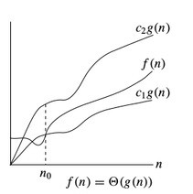

**Ω Notation**

This notation is used to find the lower bound of an algorithm i.e., time taken by algorithm can't be lower than this. In other words, this is the fastest time in which the algorithm will return a result. It's the time taken by the algorithm when provided with its best-case input. So, if a function is g(n), then the Ω representation is shown as Ω(g(n)) and the relation is shown as

*Ω(g(n)) = { f(n): there exist positive constants c, n0 such that 0 <= cg(n) <= f(n) for all n ≥ n0 }*

The above expression can be read as g(n) is a set of functions f(n) for which there exists some positive constants c and n0 such that c * g(n) is less than or equal to f(n) for all n that is greater than or equal to n0.

For example,

if f(n) = 2n² + 3n + 1

and g(n) = n²

then for c = 2 and n0 = 1, we can say that f(n) = Ω(n²)

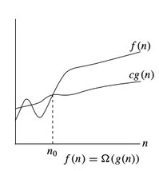

**Big O Notation**

This notation is used to find the upper bound of an algorithm i.e., time taken by algorithm can't be higher than this. It is the slowest time in which algorithm will return a result. It's the time taken by the algorithm when provided with its worst-case input. So if a function is g(n), then the Big O representation is O(g(n)) and the relation is shown as

*O(g(n)) = { f(n): there exist positive constants c, n0 such that 0 <= f(n) <= cg(n) for all n>=n0 }*

The above expression can be read as g(n) is a set of functions f(n) for which there exists some positive constants c and n0 such that f(n) is greater than or equal to 0 and less than or equal to cg(n) for all n that is greater than or equal to n0.

For example,

if f(n) = 2n² + 3n + 1

and g(n) = n² (which is nothing but the highest degree expression after removing constant).

**Proof to show that f(n) = O(g(n)):**

To prove this, we need to find positive constants c and n0 such that f(n) ≤ cg(n) for all n ≥ n0.

One way to simplify the task of finding these constants is to remove the lower order terms from f(n). The lower order terms are the terms that have a lower degree than the highest degree term (in this case, n^2).

In the function f(n) = 2n² + 3n + 1, the lower order terms are 3n and 1, because their degree is less than 2. We can remove these terms from f(n) by using the inequality 2n² + 3n + 1 ≤ 2n² + 3n² + n² for all n ≥ 1. The idea behind this inequality is that we can replace the lower order terms with a multiple of the highest degree term, without changing the overall behavior of the function for large values of n.

Let's say g(n) is the function which derived from f(n) after removing the lower order terms and replacing it with higher order tems. So

g(n) = 5n²

Big O relation is f(n) <= cg(n) i.e., 2n² + 3n + 1 <= 5n² where c = 5 and n0 = 1 (constant in original function)

Let’s assume n=1 (which satisfies n >= n0)

n=1 -> 6 <= 6

n=2 -> 15 <= 20

n=3 -> 28 <= 45

Hence **Proved**.

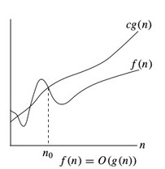

Big O notation is the most used notation to express the time complexity of an algorithm. So, we will see how to calculate the time complexity using Big O notation.

**Frequency count method:**

The time taken by the algorithm is known by assigning 1unit of time to each statement. If any statement is repeating for some number of times, we will calculate the frequency of execution of that statement. Once we are done with finding out the time units for each statement, we will sum up all the time units. If the sum is a constant, the we denote time complexity as O(1), which represents the constant time complexity. If it's a polynomial equation, then we take the higher order growth expression (remove constants of that expression if any) and we call that as time complexity. For example, O(n).

Sum of all numbers between 1 and n

1st way -> n (n+1) / 2 -> O(1)

2nd way -> single for loop -> O(n)

3rd way -> two for loops -> O(n2)

**Types of loops:**

1. While loop
   * Entry Controlled Loop
   * Used when we are unsure about how many times code should run in loop.
2. Do While loop
   * Exit Controlled loop. During the start of its execution, it first runs the code inside loop and checks condition next.
   * Used when we are unsure about how many times code should run in loop.
3. For loop
   * Used when we are sure about how many times code should run inside loop.

**Examples:**

1)

int sum = 0;

for(int i =0;i<n;i++) {

sum++;

}

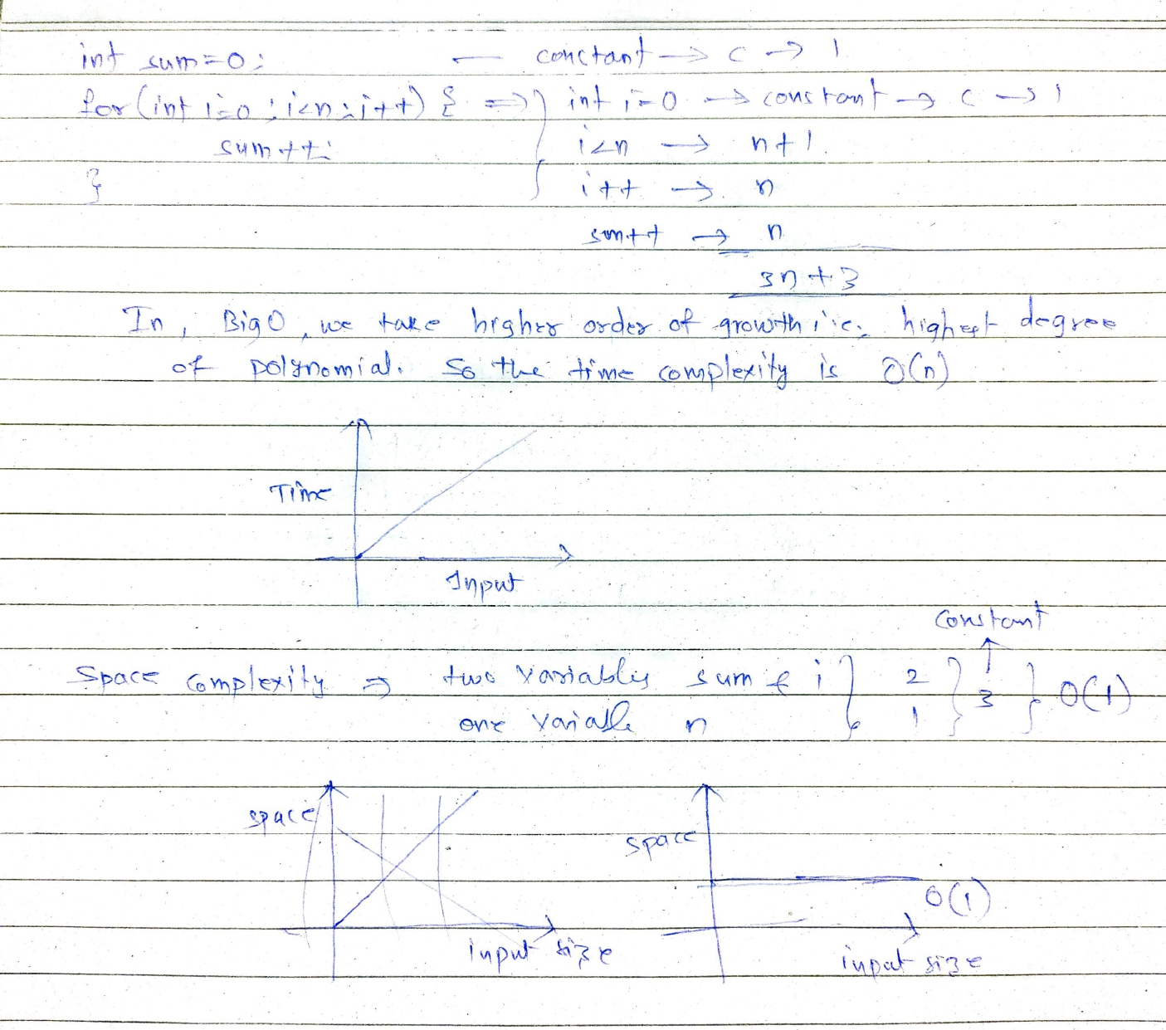

2)

int n=3;

int[n][n] A = <some_values>;

int [n][n] B = <some_values>;

int[n][n] sum = <empty>;

for(int i =0;i<n;i++) {

for(int j =0;j<n;i++) {

sum[i][j] = A[i][j] + B[i][j];

}

}

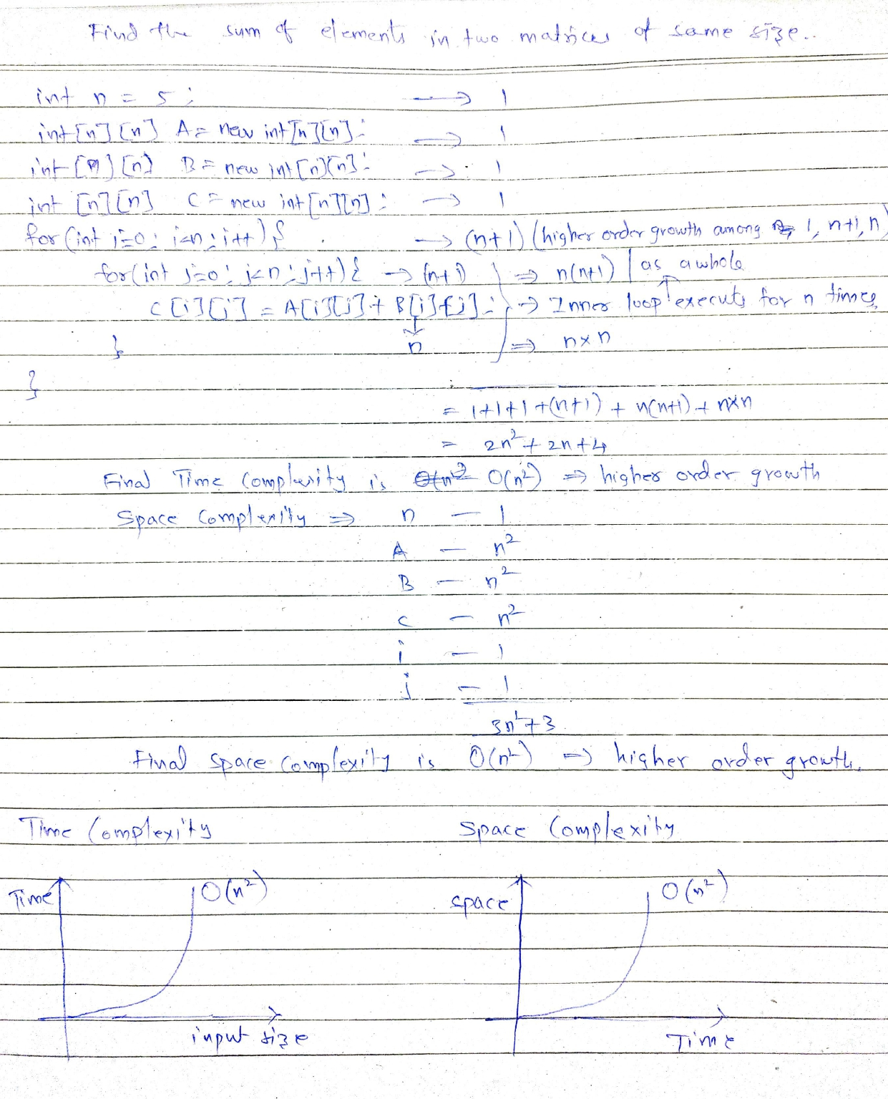

3)

int sum = 0;

for(int i=0;i<n;i++) {

for(int j=0;j<i;j++) {

sum++;

}

}

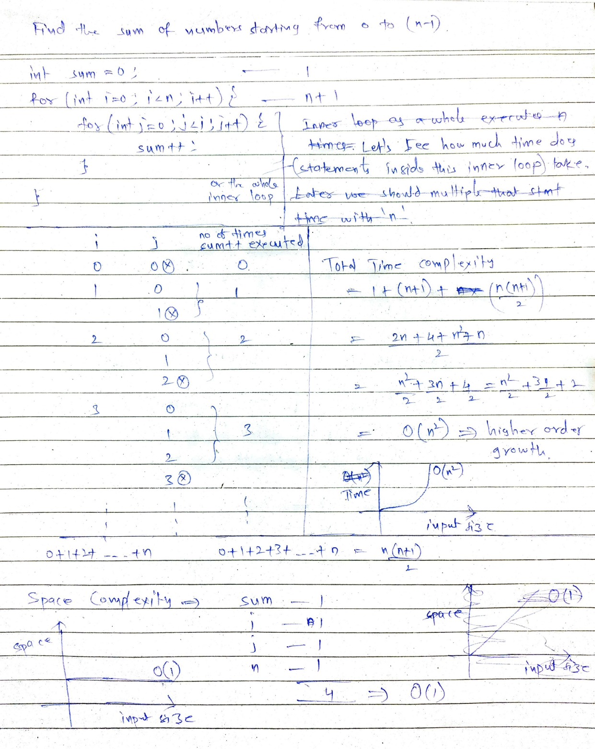

4)

int p = 0;

for(int i=0;p<=n;i++) {

p += i;

}

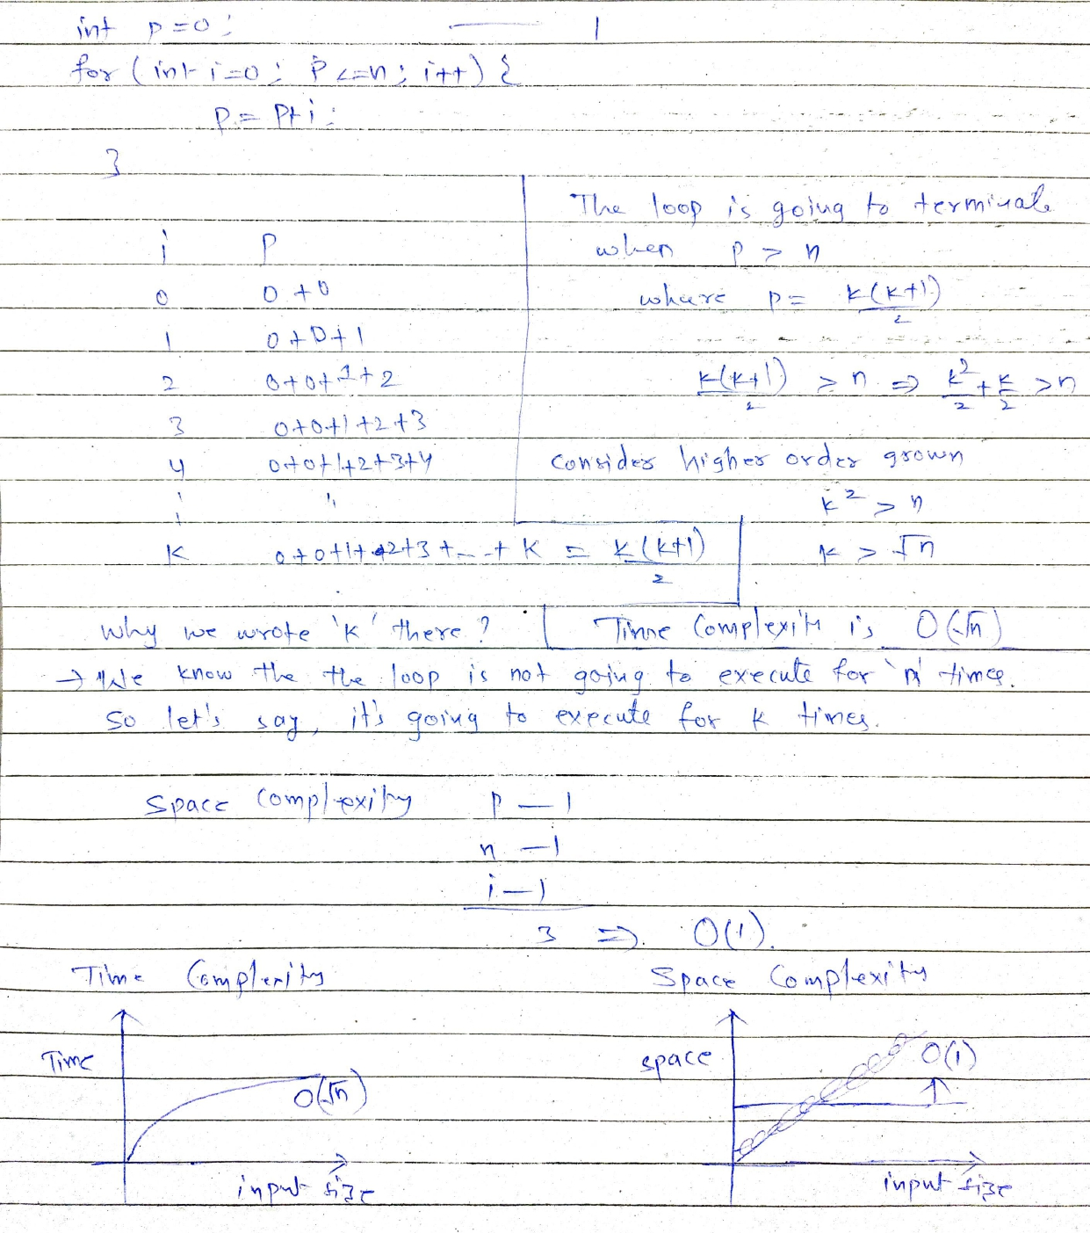

5)

for(int i=1;i<n;i=i+2) {

Statement;

}

If we see about, the statement executes for half of n times since the increment value is 2. So the time taken by statement is n/2.

Final time complexity is O(n)

Even if i=i+2, the time is n/20. Final time complexity is O(n).

6)

for(int i=1;i<n;i=i*2) {

Statement;

}

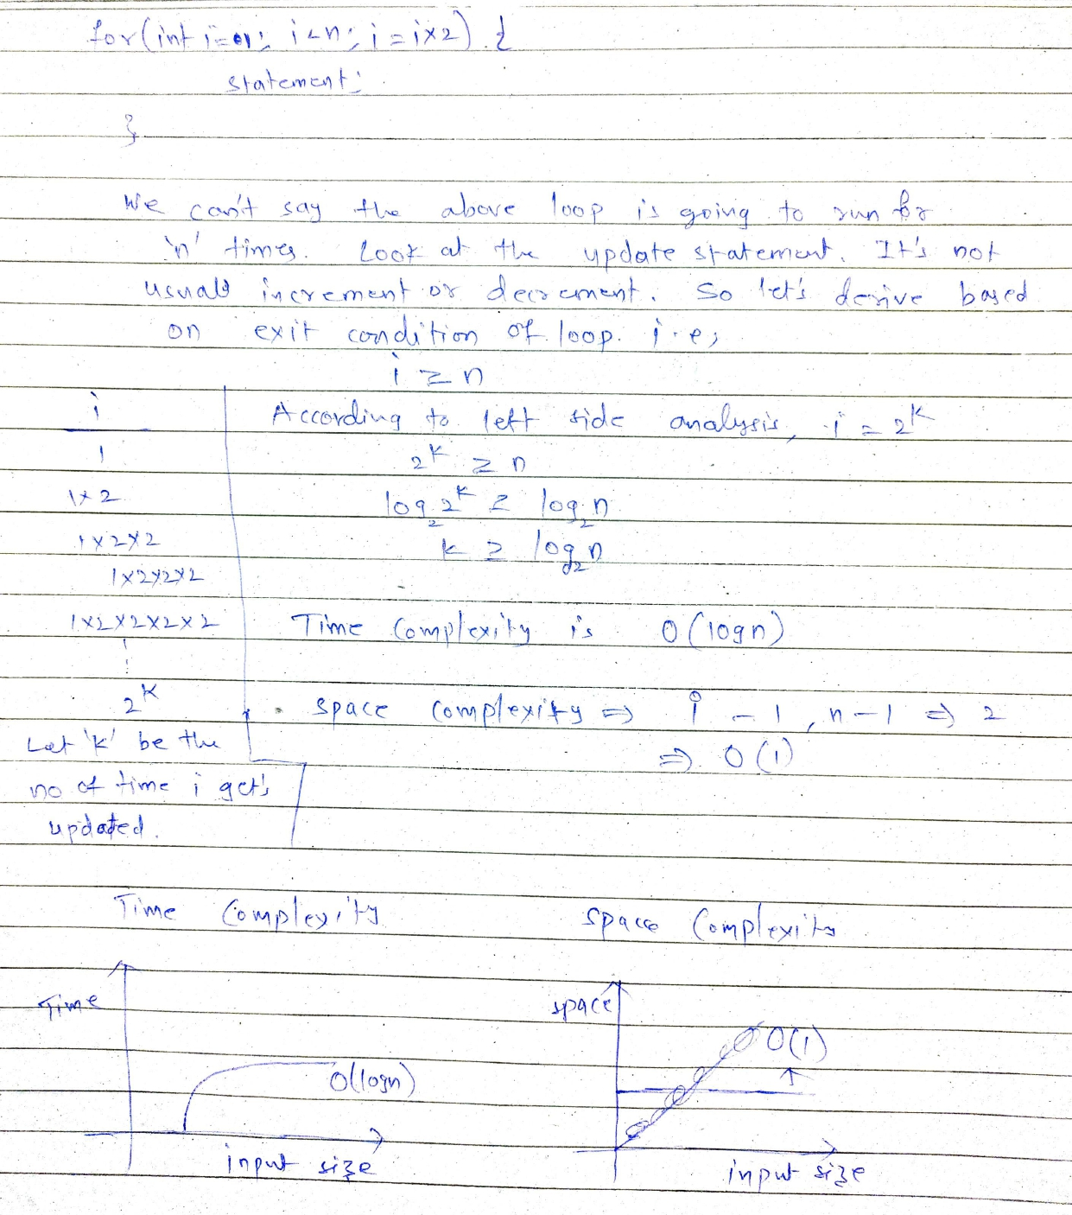

7)

for(int i=1;i<n;i=i/2) {

Statement;

}

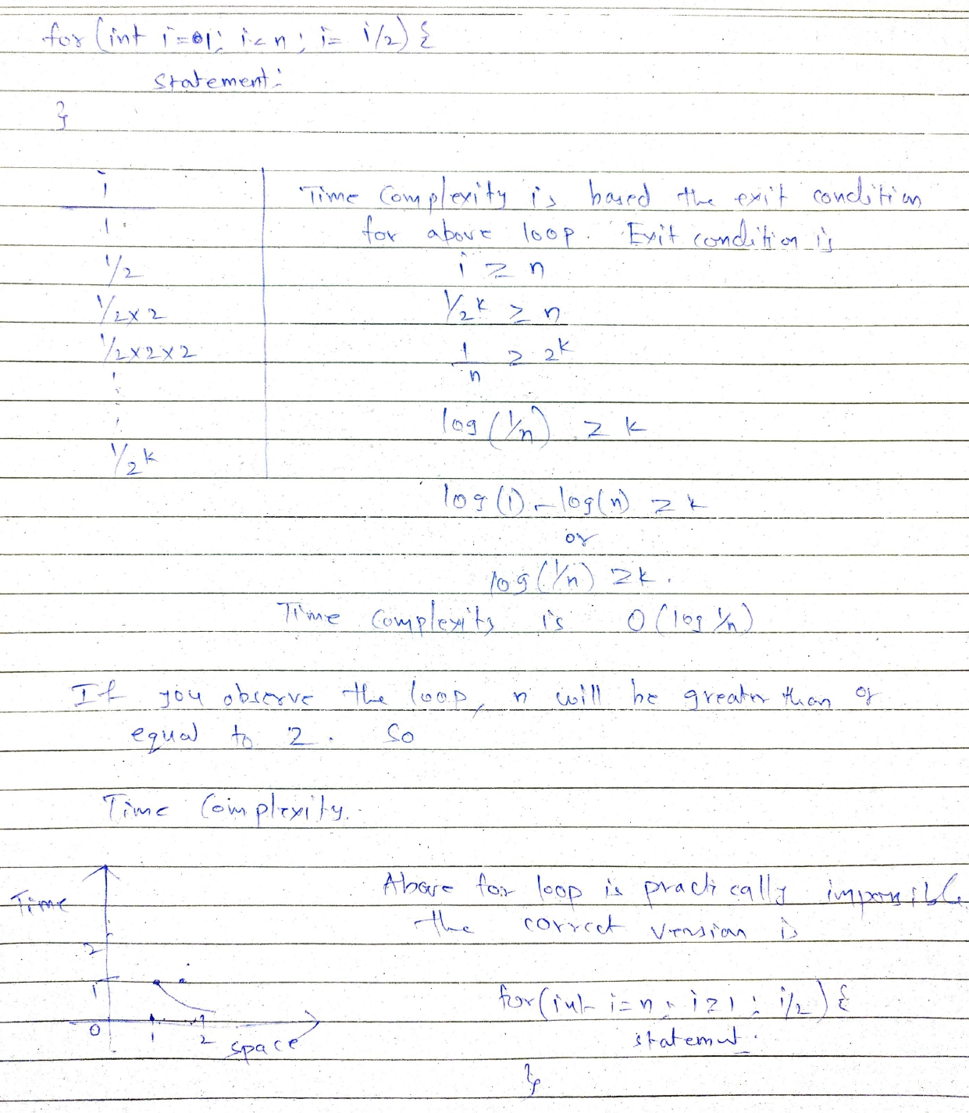

8)

for(int i = 0;i*i < n; i++) {

Statement;

}

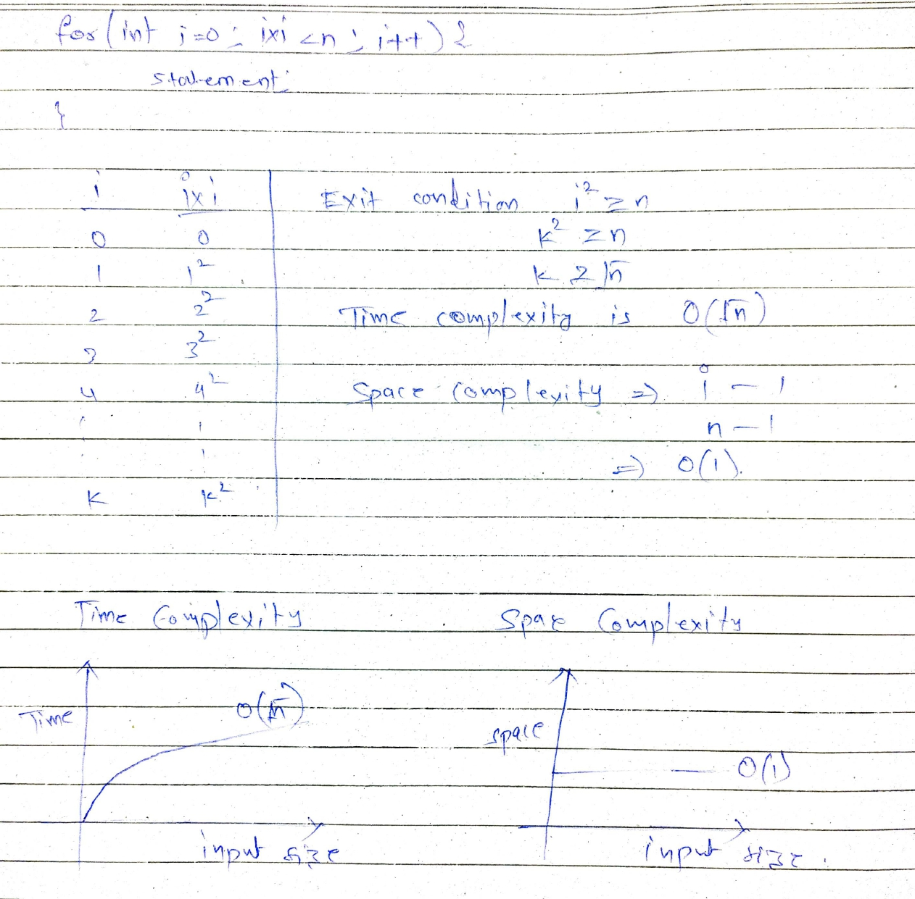

9)

p=0;

for(int i=0;i<n;i++) {

p++;

}

for(int j=0;j<p;j++) {

Statement;

}

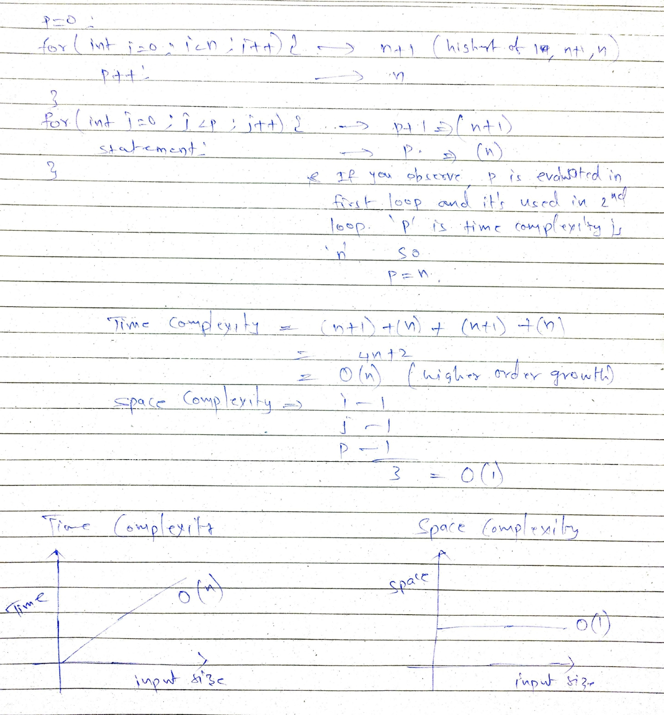

10)

for(int i=1;i<n;i++) {

for(int j=1;j<n;j=j*2) {

Statement;

}

}

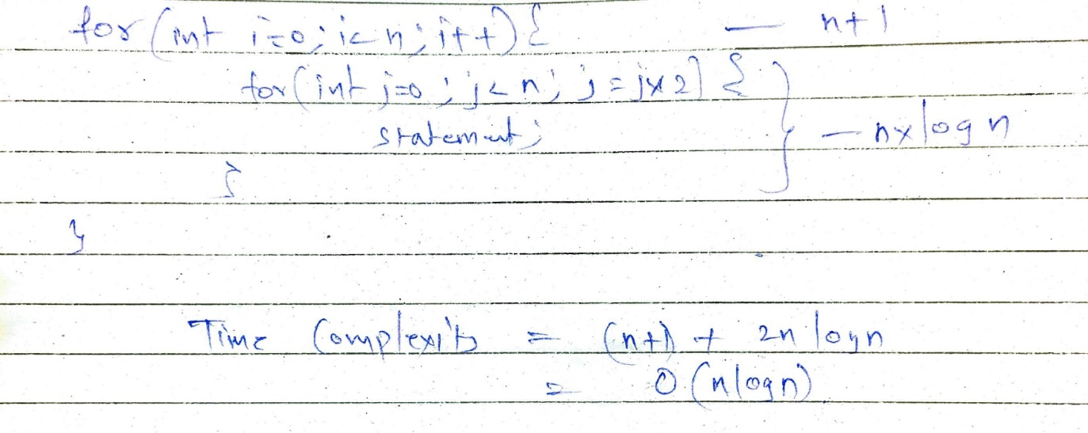

**Strategy of for loops:**

* Syntax

*for (initialization statement; condition; update statement) {*

*// statements*

*}*

The condition plays main role in determining the time complexity of for loops. Loop terminates when condition is not met.

* **Non nested for loop:** If the condition (expression) of the for loop is based on the external variables of for loop (other than variables part of initialization), the time complexity can be calculated based on the exit condition of the for loop.
* **Nested for loop:** If the inner for loop exit condition is based on the outer for loop variable (initialization), the we need to analyse how many time the inner loop ( to make it simpler, the statements inside inner for loop) is executing for the each iteration of outer loop by checking the few iterations of outer loop and find the nature of the run times of inner loop (for example, if it's sum of 1 to n, then equation is n(n+1) / 2)

**Strategy of while condition & If condition:**

* We know that there is a difference between do while and while loops. But, for & while are almost same. Whatever we implement with for loops, we can implement the same using while loop as well and vice versa.
* We have to study while and do while loops to determine time complexity because most of the times, only termination condition is visible and no of iterations is unknown. Whereas, no of iterations will be visible in for loops (might not be straight forward) and determining time complexity is easy.
* If there is a conditional statement in an algorithm, then we get different time complexities based on the condition of that statement. Whatever the number of time complexities it may be, we are always concerned with worst case. So pick the worst case out of different times and call it as the time complexity of that algorithm.
* While loop Examples:

1)

*i=0;*

*while(i<n) {*

*Statement;*

*i++;*

*}*

Time complexity - O(n)

Converting to for loop

*for(int i=0;i<n;i++) {*

*Statement;*

*}*

2)

*i=1;*

*while(i<n) {*

*Statement;*

*i=i*2;*

*}*

Time complexity: n/2 - which is equal to O(n)

*for(int i=1;i<n;i=i*2) {*

*Statement;*

*}*

3)

i=1;

k=1;

while(k<n) {

Statement;

k = k+i;

i++;

}

|  |  |
| --- | --- |
| I | K |
| 1 | 2 |
| 2 | 2+2 |
| 3 | 2+2+3 |
| 4 | 2+2+3+4 |
| … | … |
| m | m(m+1) / 2 |

Exit condition is k >= n

m(m+1)/2 >= n

m(square) >= n

m >= (square root)n

So time complexity is O(square root of n)

k=1;

for(int i=1;k<n;i++) {

Statement;

k= k+I;

}

4)

int a = 16;

int b = 12;

int largest = a > b ? a : b;

int smallest = b < a ? b : a;

while(smallest != 0) {

int rem = largest % smallest;

largest = smallest;

smallest = rem;

}

Theorem: a % b < a/2 for all a > b

|  |  |
| --- | --- |
| Largest | Smallest |
| 16 | 12 |
| 12 | 4 |
| 4 | 0 |

L0 S0

S0 S1

S1 S2

S2 S3

…

We can assume L=S from above

We know L % S < L/2

S(i) % S (i+1) < S(i) / 2

So, as per the above derivation, in every iteration, the smallest number is getting reduced half (more than half sometimes).

The exit condition is smallest != 0

smallest / 2(power n) != 0

smaller != 2(power n)

log(smallest) != n

So the time complexity is O(log(smallest))

5)

public static void func(n) {

If(n>5) {

Statement;

} else {

for(i=0;i<n;i++) {

Statement;

}

}

}

Best case Time Complexity - O(1) -- when n>5

Worst case (final) time complexity - O(n) -- when n<5

**Types of time complexity functions:**

* O(1) - Constant Time Complexity
* O(logn) - Logarithmic Time Complexity
* O(n) - Linear Time Complexity
* O(n square) - Quadratic time complexity
* O(n cube) - Cubic Time Complexity
* O(2 power n or 3 power n or k power n) - Exponential Time Complexity

**Comparison of time complexity functions:**

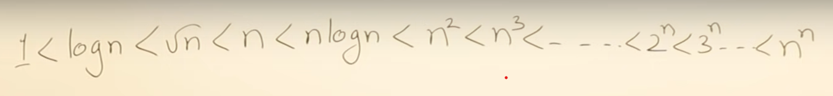

**Graphs of various time complexity functions:**

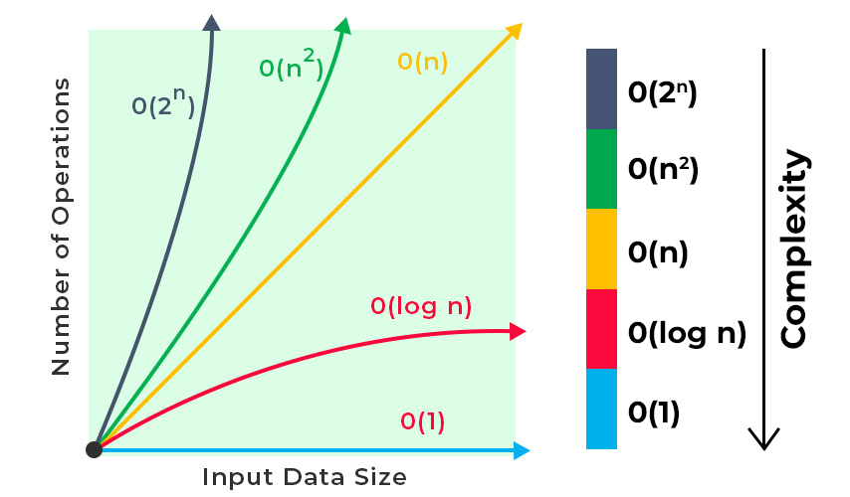

Other image for reference:

